

**EXPERIMENT-06**

NAME :- ASHISH RAJ UID :- 20BCS5736

SECTION :- 705/B SEMESTER :- 6TH

SUBJECT :- MAD Lab SUBJECT CODE :- 20CSP-356

BRANCH:- BE-CSE DATE OF PERFORMANCE:- 12/04/23

**AIM :-** Creating the Application Choosing Options RadioButton

# OBJECTIVE :-

# To create an android project and design an android app using Radio Buttons.

# CODE :-

# Java file

# package com.teachnook.radiobutton;

# import android.support.v7.app.AppCompatActivity;

# import android.os.Bundle;

# import android.view.View;

# import android.widget.Button;

# import android.widget.RadioButton;

# import android.widget.RadioGroup;

# import android.widget.Toast;

# public class MainActivity extends AppCompatActivity {

# private RadioGroup radioGroup;

# Button submit, clear;

# @Override

# protected void onCreate(Bundle savedInstanceState)

# {

# 

# 

# super.onCreate(savedInstanceState);

# setContentView(R.layout.activity_main);

# submit = (Button)findViewById(R.id.submit);

# clear = (Button)findViewById(R.id.clear);

# radioGroup = (RadioGroup)findViewById(R.id.groupradio);

# radioGroup.clearCheck();

# radioGroup.setOnCheckedChangeListener(

# new RadioGroup

# .OnCheckedChangeListener() {

# @Override

# public void onCheckedChanged(RadioGroup group,int checkedId)

# {

# RadioButton radioButton= (RadioButton)group.findViewById(checkedId);

# }

# });

# submit.setOnClickListener(new View.OnClickListener() {

# @Override

# public void onClick(View v)

# {

# int selectedId = radioGroup.getCheckedRadioButtonId();

# if (selectedId == -1) {

# Toast.makeText(MainActivity.this,"No answer has been selected",Toast.LENGTH_SHORT)

# .show();

# }

# else {

# RadioButton radioButton = (RadioButton)radioGroup.findViewById(selectedId);

# Toast.makeText(MainActivity.this,radioButton.getText,Toast.LENGTH_SHORT)

# .show();

# 

# }

# }

# });

# clear.setOnClickListener(new View.OnClickListener() {

# @Override

# public void onClick(View v)

# {

# radioGroup.clearCheck();

# }

# });

# }

# }

# XML file

# <?xml version="1.0" encoding="utf-8"?>

# <LinearLayout xmlns:android="http://schemas.android.com/apk/res/android"

# xmlns:tools="http://schemas.android.com/tools"

# android:layout_width="match_parent"

# android:layout_height="match_parent"

# android:background="#00B0FF"

# tools:context=".MainActivity"

# android:backgroundTintMode="screen"

# android:orientation="vertical">

# <TextView

# android:id="@+id/question_show"

# android:layout_width="match_parent"

# android:layout_height="wrap_content"

# android:layout_marginTop="50sp"

# android:text="Select your Subject?"

# android:textAlignment="center"

# android:textSize="28sp"

# android:textStyle="bold" />

# 

# <RadioGroup

# android:id="@+id/groupradio"

# android:layout_width="300dp"

# android:layout_height="wrap_content"

# android:layout_marginLeft="40sp"

# android:layout_marginTop="30sp"

# android:padding="20sp">

# <RadioButton

# android:id="@+id/rbtn1"

# android:layout_width="match_parent"

# android:layout_height="30dp"

# android:text="DBMS"

# android:textSize="20sp"

# android:textStyle="bold"/>

# <RadioButton

# android:id="@+id/rbtn2"

# android:layout_width="match_parent"

# android:layout_height="30dp"

# android:text="C/C++ Programming"

# android:textSize="20sp"

# android:textStyle="bold"/>

# <RadioButton

# android:id="@+id/rbtn3"

# android:layout_width="match_parent"

# android:layout_height="30dp"

# android:text="Data Structues"

# android:textSize="20sp"

# android:textStyle="bold"/>

# 

# 

# <RadioButton

# android:id="@+id/rbtn4"

# android:layout_width="match_parent"

# android:layout_height="30dp"

# android:text="Algorithms"

# android:textSize="20sp"

# android:textStyle="bold"/>

# </RadioGroup>

# <Button

# android:id="@+id/submit"

# android:layout_width="match_parent"

# android:layout_height="wrap_content"

# android:layout_marginLeft="50sp"

# android:layout_marginRight="50sp"

# android:layout_marginTop="40sp"

# android:backgroundTint="#FF5722"

# android:text="Submit"/>

# <Button

# android:id="@+id/clear"

# android:layout_width="match_parent"

# android:layout_height="wrap_content"

# android:layout_marginLeft="50sp"

# android:layout_marginRight="50sp"

# android:layout_marginTop="40sp"

# android:backgroundTint="#FF5722"

# android:text="CLEAR"/>

# </LinearLayout>

# 

# OUTPUT :

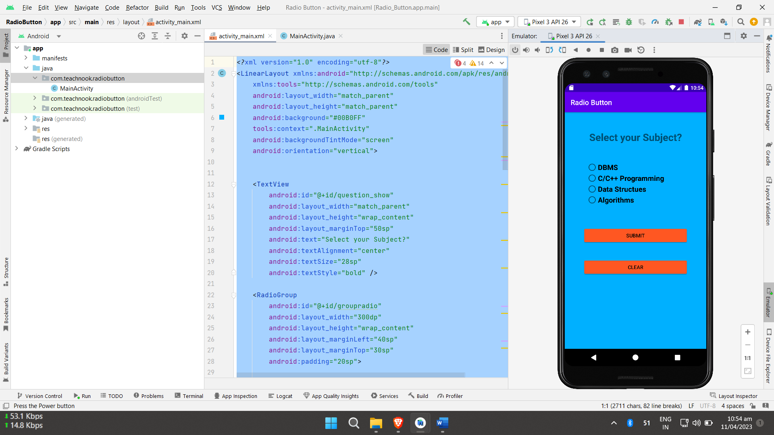 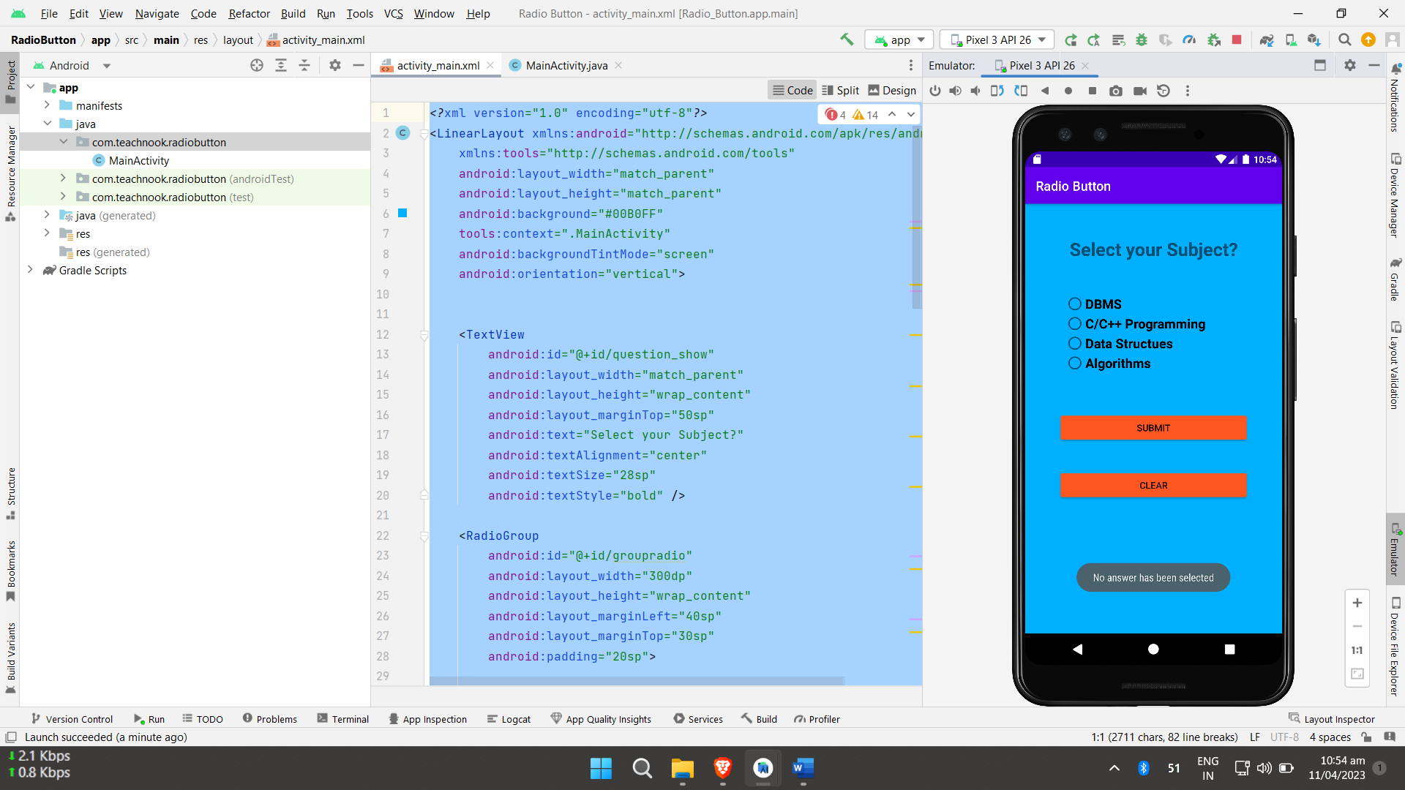 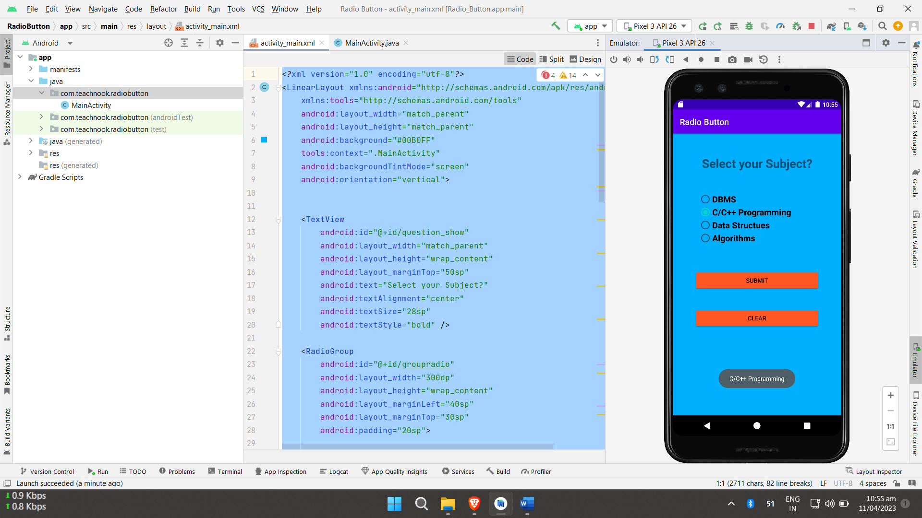

**Learning outcomes (What I have learnt):**

● Learned the concept of Radio Button in Android Studio

● Learnt about the Functionality of Radio Button